See how closely Ohio school report card grades trend with district income
By Rich Exner, cleveland.com September 17, 2019
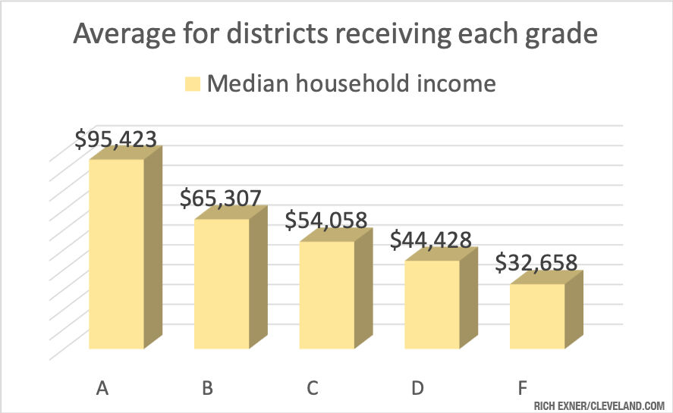
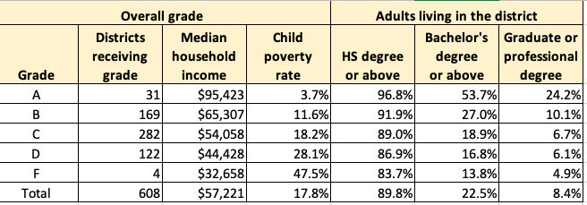CLEVELAND, Ohio - The latest set of Ohio school report cards not only provided a scorecard for each district statewide - they once again drove home the point that wealthier districts do better on such reports. For example, incomes in the "A" districts were three times higher than those in the "F" districts, and the child poverty rate was 13 times higher in the worst performing districts, cleveland.com found.
To get an idea of how closely report card grades from the Ohio Department of Education follow demographic factors, cleveland.com compared those grades to U.S. Census Bureau community data for household income, child poverty and the education level of the adults.
In nearly every key report card category, the trends followed census data closely. For example, taking the median household income for each district, the average among those getting "A" overall grades was $95,423. It was $65,307 for B-graded districts, $54,058 for C-graded districts, $44,428 for D-graded districts and $32,658 for F-graded districts. In the A districts, 58.5% of the adults age 25 and older have at least a bachelor's degree. That share drops to 17.1% for D-graded districts and 16.3% for F-graded districts.
There are outliers, of course. They are highlighted at this link, ranking each Ohio school district while factoring in income. But overall, the trends hold true.
Scroll below to learn more. The descriptions for each category shown below are from the Ohio Department of Education. The census data cleveland.com used to make the calculations is from the 2017 American Community Survey.
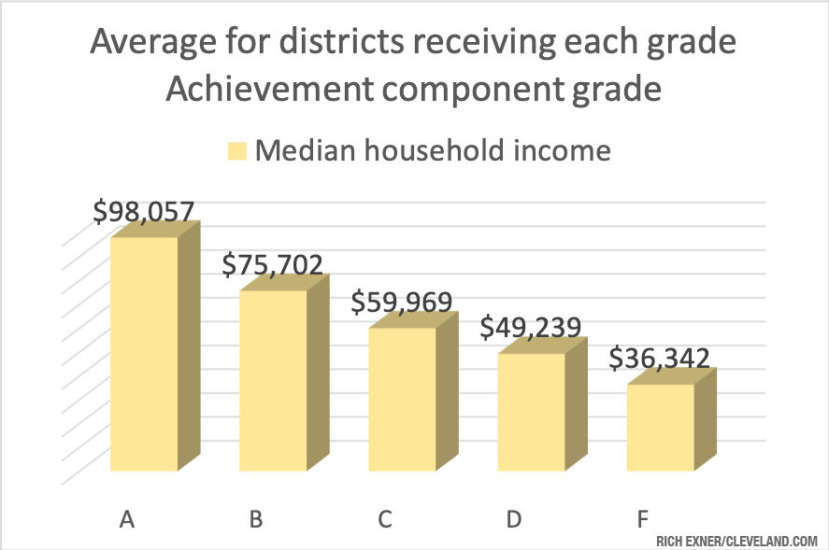
Achievement component grade The Achievement component represents whether student performance on state tests met established thresholds and how well students performed on tests overall. A new indicator measures chronic absenteeism.

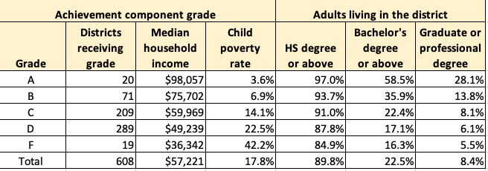

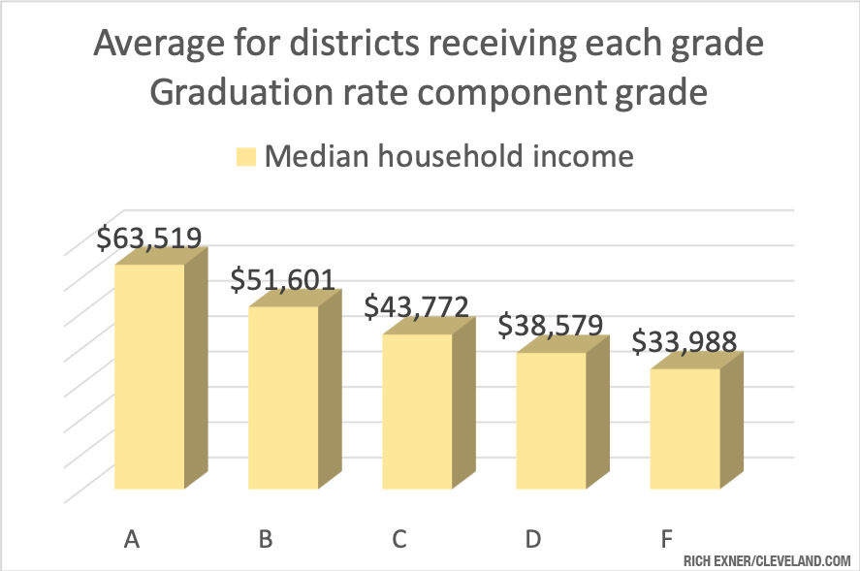
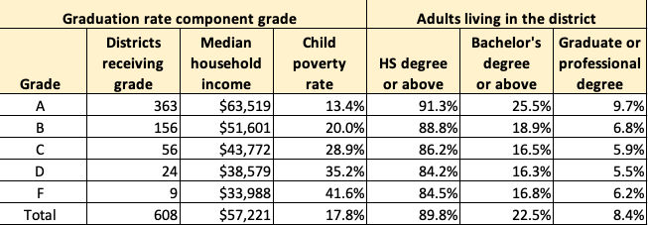
Graduation rate component The Graduation rate component looks at the percent of students who are successfully finishing high school with a diploma in four or five years.
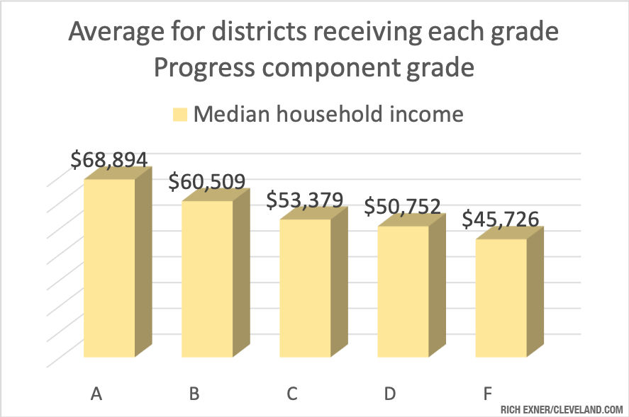
Progress component The Progress component looks closely at the growth that all students are making based on their past performances.
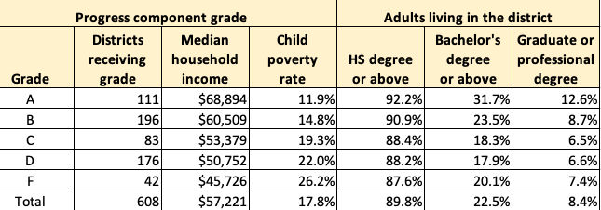

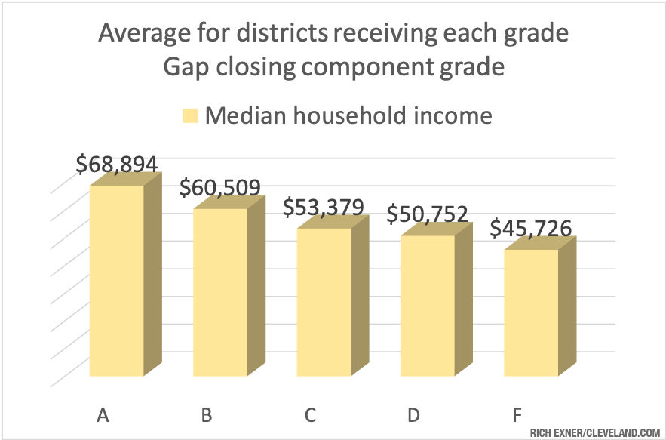
Gap closing component The Gap closing component shows how well schools are meeting the performance expectations for our most vulnerable students in English language arts, math, graduation and English language proficiency.
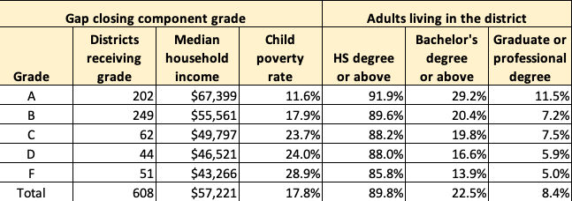

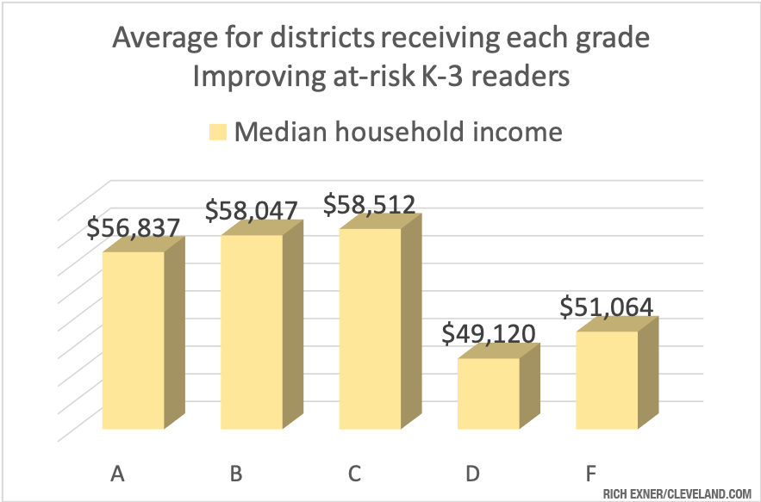
Improving at-risk K-3 readers component This component looks at how successful the school is at improving at-risk K-3 readers.

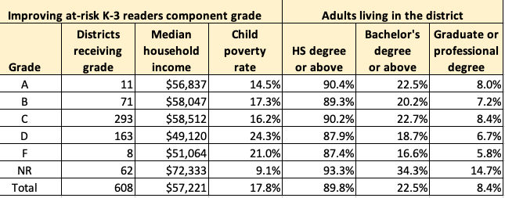

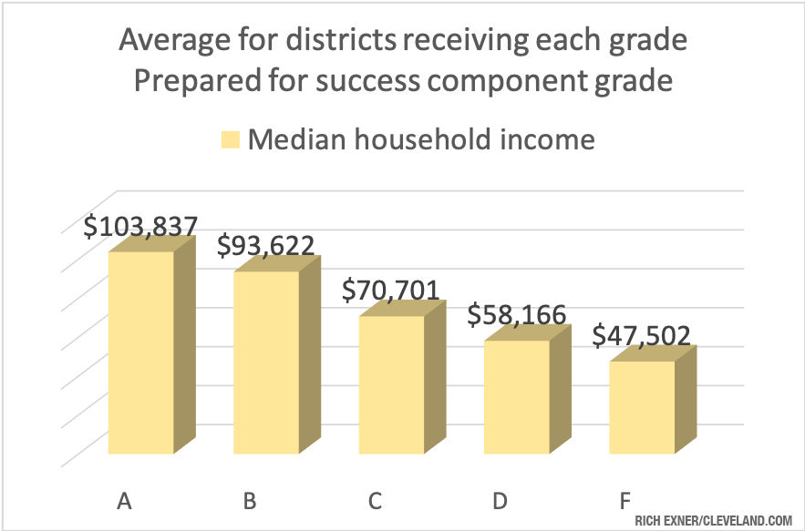
Prepared for success component Whether training in a technical field or preparing for work or college, the prepared for success component looks at how well prepared Ohio’s students are for all future opportunities.
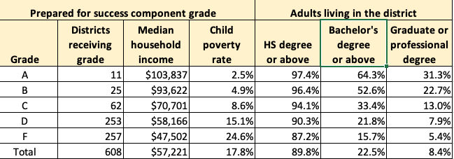

Rich Exner, data analysis editor for cleveland.com, writes about numbers on a variety of topics. Follow on Twitter @RichExner. Go to cleveland.com/datacentral for other data-related stories and analysis.

